Exercises

Please read - If you intend to use this resource in a classroom setting, you must agree to cite George Sheldrick, Georg-August-Universität Göttingen.
Contents
Exercises 1
1. Symmetry Elements 1
2. Symmetry, Point Groups 1
3. Unit cells, Bravais Lattices 1
4. Space Groups 1
5. Resolution, Bragg Planes 2
6. Laue Group, Systematic Absences 2
7. Space Groups 3
8. Phases 4
9. Patterson Methods 4
10. Atomic Displacement Parameters 5
11. Disorder, Neutron Diffraction 5
12. Systematic Absences, Powder Diffraction 5

1. Symmetry Elements

Q1 Which symmetry elements are present in the following, and to which point groups do they belong (in both systems)?
- H₂O₂ (gauche)
- SF₄
- B₂H₆
- C₂H₆ (staggered and eclipsed)
- H₂C=C=CH₂

2. Symmetry, Point Groups

Q1. Why do virus shells usually possess a high symmetry, and why do biological macromolecules often crystallize in space groups of higher symmetry than small molecules?
Q2. Which 10 crystallographic point groups would be suitable for oligomers of chiral monomers (e.g. proteins) and how many monomers would make up the oligomers in each case?
Q3. Attempt to assign the point group of a tennis ball, taking the stripe into account but ignoring any text.

3. Unit cells, Bravais Lattices

Q1. Why do the 14 Bravais lattices not include tetragonal C and tetragonal F?
PtS (mineral name Cooperite) is tetragonal, a = b = 3.47 Å, c = 6.10 Å.
The following atoms are present in the unit-cell:
Pt: 0 ½ 0 and ½ 0 ½;
S: 0 0 ¼ and 0 0 ¾.

Q2. Draw four unit-cells in projection viewed down b.
Q3. Draw four unit-cells in projection viewed down c. Describe the co-ordination geometry of the Pt and S atoms. Does it make chemical sense?
Q4. What is the shortest Pt–S-distance?
Q5. Which type of lattice (P, A, B, C, I or F) is present?
Q6. Which of the following symmetry elements are present: 1, 4, 4₁, 4₂, 4₃, 4?

4. Space Groups

Q1. The space group P2₁/c is the most common for inorganic structures, but it has not yet been observed for protein crystals. Is there a reason for this?

Q2. Biphenyl (C₆H₅–C₆H₅) crystallizes in the space group P2₁/c with a = 7.82, b = 5.58, c = 9.44 Å, α = 90, β = 94.62, γ = 90º. The density is 1.25 Mg m^{–3}. Calculate the volume of the cell and so the number of biphenyl molecules in it. Does it fit the 18 Å³ rule? How many molecules constitute one asymmetric unit? How can this be reconciled with the number of asymmetric units per cell? Is the molecule planar in the crystal? Why are the molecular conformations different in the crystal and in the gas phase?

Volume of the unit-cell
= abc [ 1 – cos²α – cos²β – cos²γ + 2cosα.cosβ.cosγ ]^{½}
= abc.sin(β) when α = γ = 90º (monoclinic)

5. Resolution, Bragg Planes

Q1. Image plate X-ray detectors usually stand perpendicular to the primary beam that passes through the middle of the circular (340 mm diameter) active area of the detector. Calculate the maximum resolution that can be reached with a distance of 45 mm between crystal and detector
- with CuKα radiation, λ = 1.5418 Å
and
(b) with MoKα, λ = 0.7107 Å.

Q2. Draw a projection of an orthorhombic unit-cell with a = 7.0, b = 8.0 and c = 12.0 Å viewed down a. Draw in the planes (012) and calculate their distance apart using Pythagoras and the formula for the area of a triangle (½gh where g is the length of the base and h the height perpendicular to it).
Q3. In a separate drawing show part of the 0kl layer of the reciprocal lattice and calculate b*, c* and thus d*(012). How are d and d* related to one another?

6. Laue Group, Systematic Absences

Q1. Estimate the approximate percentage of small molecule structures in which the space group can be determined unambiguously from the systematic absences!

Q2. Can all triclinic, monoclinic and orthorhombic space groups be distinguished unambiguously for protein crystals?

Q3. Four layers of reciprocal space are shown below. Determine the Laue group, the systematic absences and the possible space groups in the given orientation of the axes. Which space group is more likely if the reflection intensity distribution is taken into account? Luckily, in this case it should not be necessary to re-orientate the axes!

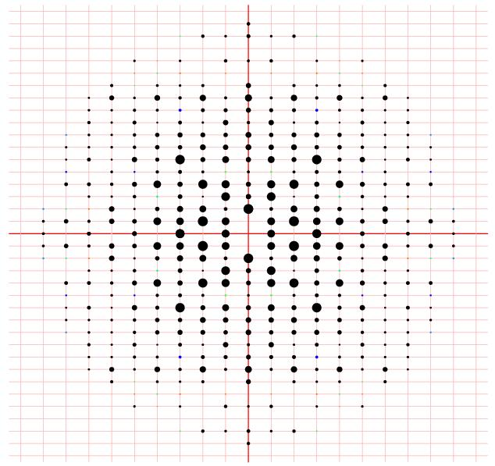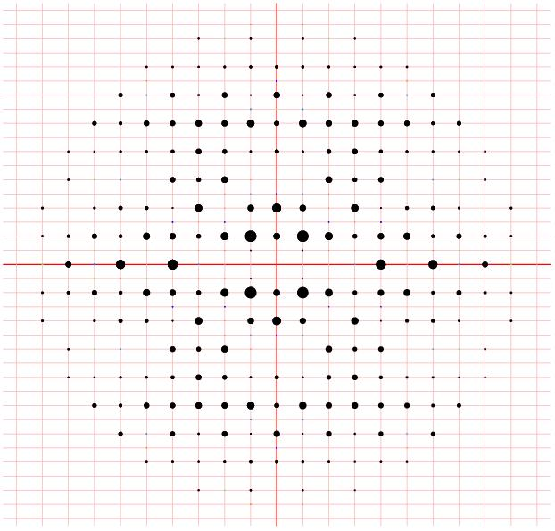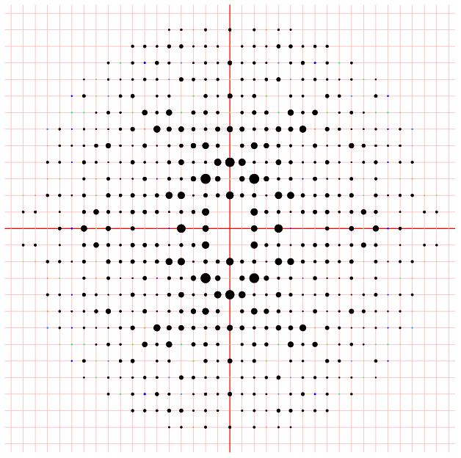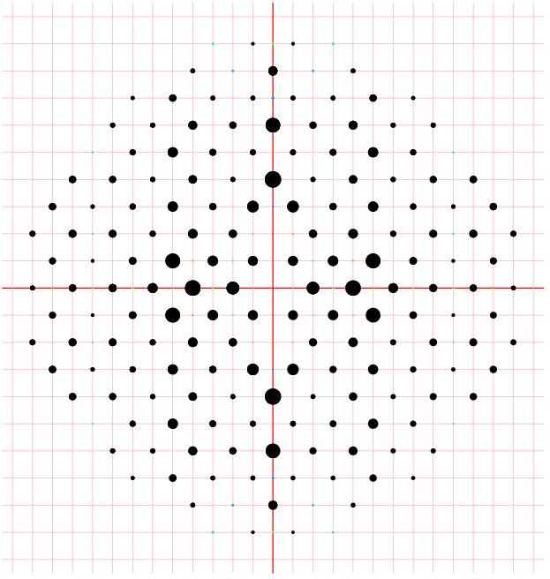
00ℓ
0k0
h00
h01
hk0-layer
hk1-layer
h0ℓ-layer
0kℓ-layer
h00
0k0
00ℓ
0k1

7. Space Groups

Q1. Find the 11 enantiomorphic pairs of space groups (hint: all are of course chiral and possess 3_{N}, 4_{N} or 6_{N} axes).

Q2. The incomplete picture should show the space group I4₁. Add the effect of the I-lattice by marking the additional symmetry elements and molecules that it generates. Why is there no space group I4₃?

..
..
..
..
+
½+
¼+
¾+
a
b
0
1
1

Q3. Assign the space group of a tetragonal crystal with the systematic absences:
hkℓ, h+k+ℓ ≠ 2n; hk0, h ≠ 2n or k ≠ 2n; hhℓ, 2h+ℓ ≠ 4n.

8. Phases

Q1. For a structure in space group P1, the reflections 1 1 0 und 2 2 0 were both strong. What can one deduce about their phases
(a) graphically and (b) with the help of the triplet equation?

Q2. What are the phases of reflections

- h+k+ℓ=2n

and

- h+k+ℓ≠2n (where n is a whole number)
when there is one heavy atom at x=½, y=½, z=½?

Q2. For a small structure in the space group P1 the reflections 1 3 2, 4 –1 1, 5 2 3 and 6 5 5 are all very strong. Estimate the phase of the reflection 6 5 5 when the phase of 1 3 2 is 40º and the phase of 4 –1 1 is 270º. Why is this prediction less reliable when
- the structure is larger
or
(b) the reflection 5 2 3 is weaker?

9. Patterson Methods

Q1. An atom at x, y, z in the space group P2₁/c generates three symmetry equivalents: –x, ½+y, ½–z; –x, –y, –z; x, ½–y, ½+z. Express the coordinates of the Patterson maxima generated from a single atoms by means of a 4x4 difference table.

Q2. Combine these coordinates into a table with columns X, Y, Z and m. Symmetry equivalent vectors should be indicated with brackets and ‘±’ symbols as in the following table.

Q3. The following strong Patterson peaks were observed for an organogold compound in the space group P2₁/c. Where is the gold atom (there are several equally good correct answers)?
X Y Z Höhe
0.00 0.00 0.00 1.0
± { 0.16 0.50 0.14 } 0.4
± { 0.00 0.04 0.50 } 0.4
± { 0.16 ±0.46 0.64 } 0.2

10. Atomic Displacement Parameters
Q1. A typical AsF₆– anion showed As–F bond lengths of 1.66 Å at room temperature with the following atomic displacement parameters:

As: U = 0.05 Å² in all directions;
F: U = 0.05 Å² along As–F and 0.40 Å² at right angles to it.
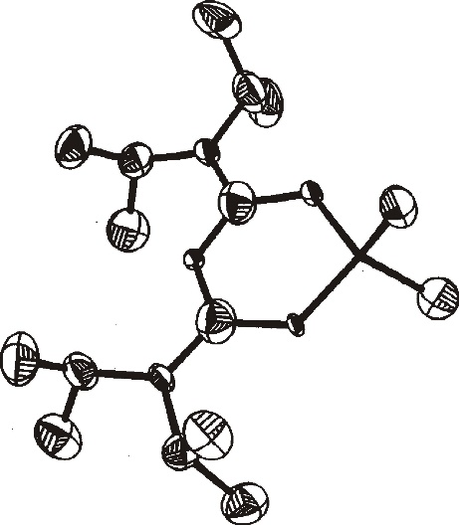
How long would the As-F bond appear to be using low-temperature data?
Q2. The reaction between a liquid Na/K alloy, ^{i}Pr₂NBF₂ and 4-methyl-pyridine led to the structure shown when all atoms were refined as carbon (50% ellipsoids). The isotopic distribution in the mass spectrum indicated that there were two boron atoms in the molecule and gave a molecular weight (for the ¹¹B₂ species) of 328. Attempt to assign the atoms!

11. Disorder, Neutron Diffraction

Q1. The crystal structure of the product of the proposed reaction
CuCl + 5F₂ [ClF₆]⁺ [CuF₄]⁻ (?)
Was given as a proof. The reaction was carried out in a quartz tube. Why was the crystal light blue and surprisingly stable in air?
Q2. Interpret the disorder of the ClO4- ions!
Q3. Why can hydrogen atom positions be determined more precisely by neutron diffraction of deuterated compounds than by:
a) X-ray diffraction
Or
b) neutron diffraction of the corresponding ¹H-compounds?
Is this also a case when only a third of the ¹H atoms can be replaced by ²H?

12. Systematic Absences, Powder Diffraction

Q1. For a cubic crystal sin2θ =Nλ²/4a² with N = h²+k²+l². Which N-values up to N=20 inclusive are allowed for:
a) a P-lattice
b) an I-lattice (h+k+l = 2n)
c) a F-lattice (h,k and l either all even or all odd)?
Q2. How can one distinguish between P, I and F-lattices using the powder diffraction pattern of a cubic compound?
Q3. With λ = 1.54178 Å the following powder lines were observed for powdered copper:
Θ = 21.68, 25.25, 37.10, 45.00, 47.63, 58.53, 68.27 nd 72.50. Attempt to index lines and deduce unit cell dimension a.
Q4. Suggest a simple structure that would be consistent with these results. How long is the shortest Cu-Cu distance in the metal?

