Exercises

Please read - If you intend to use this resource in a classroom setting, you must agree to cite Mike Zdilla, Temple University. Answers to the exercises are available upon request.
Contents
Exercises 1
1a. Unit Cells 1
1b. Unit Cells 2
1c. Unit Cells 2
2. Bragg Equation, Lattice Planes 2
3. Reciprocal Lattice 2
3w. Reciprocal Lattice Worksheet 3
4a. Ewald Sphere, Structure Factors 4
4b. Structure Factors 4
5a. Symmetry and Space Group 4
5b. Symmetry and Space Group 7
6a. Patterson 10
6b. Patterson 13
6w. Patterson Worksheet 16
7. Direct Methods 19
8a. Disorder, Anomalous Dispersion 20
8b. Disorder, Weighting, Anomalous Dispersion, Quasicrystals 21
9. Anomalous Dispersion, Twinning 23

1a. Unit Cells

1. For a unit cell which is orthorhombic P, a = 7 Å, b = 13 Å, c = 25 Å,
a. what is the distance in Å between an atom with coordinates 0,0,0, and an atom
with coordinates 0, 0, ½?
b. what is the distance in Å between an atom at 0, 0, 0 and ¼, ½, 0?
c. what is the value of angle γ?
2. Describe why there is no I-centered triclinic cell. Draw a diagram to assist your explanation

1b. Unit Cells

1. For a unit cell which is orthorhombic P, a = 12 Å, b = 13 Å, c = 19 Å,
a. what are the coordinates (x,y,z) of an atom sitting on the a axis, 6 Å from the origin?
b. what is the distance in Å between an atom at 0, 0, 0 and ¼, ½, 0?
c. what is the value of angle γ?
2. Describe why there is no A-centered triclinic cell. Draw a diagram to assist your explanation.
3. Is it possible to have a triclinic cell with all 90 degree angles? Explain

1c. Unit Cells

1. For a unit cell which is orthorhombic P, a = 12 Å, b = 13 Å, c = 19 Å,
a. what are the coordinates (x,y,z) of an atom sitting on the b axis, 4 Å from the origin?
b. what is the distance in Å between an atom at 0, 0, 0 and 1/3 , 0, 1/4?
c. what is the value of angle α?
2. Describe why there is no I-centered triclinic cell. Draw a diagram to assist your explanation.
3. Is it possible to have a hexagonal cell with all 90 degree angles? Explain.

2. Bragg Equation, Lattice Planes

1. In the pictures of the unit cells below, draw the following lattice planes.

001 212 310
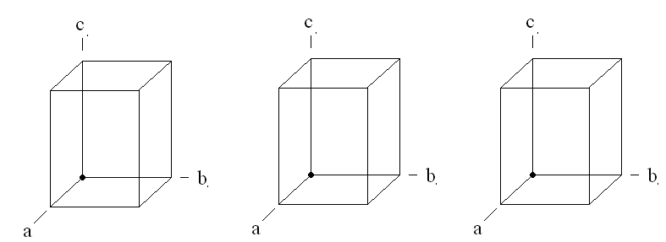
2. In an experiment using Cu Kα radiation, a reflection is seen which has a θ diffraction angle of 59˚. What is the lattice spacing d for this reflection.
3. Demonstrate that the quadratic form for the Bragg equation for an orthorhombic cell is a special case of the quadratic Bragg equation for the monoclinic cell.

3. Reciprocal Lattice

1. In the pictures of the orthorhombic unit cells below, draw the following lattice planes:
100 230 231
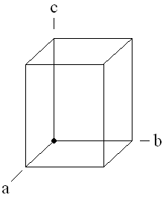

Based on the three planes above, label the three corresponding reciprocal lattice points in the reciprocal lattice provided below. Indicate the hkl index next to each point. The origin of the reciprocal axes is marked with an “O.”

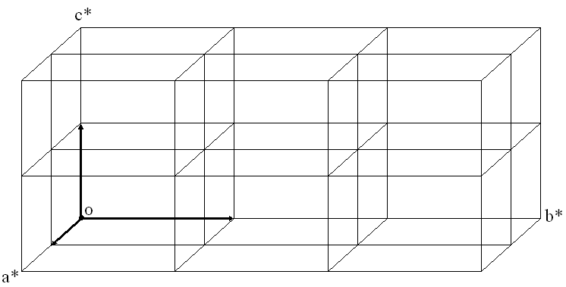

2. In class, we proved that the Bragg equation cannot be satisfied when d < λ/2. Use the Ewald construction to demonstrate this phenomenon graphically.

3w. Reciprocal Lattice Worksheet

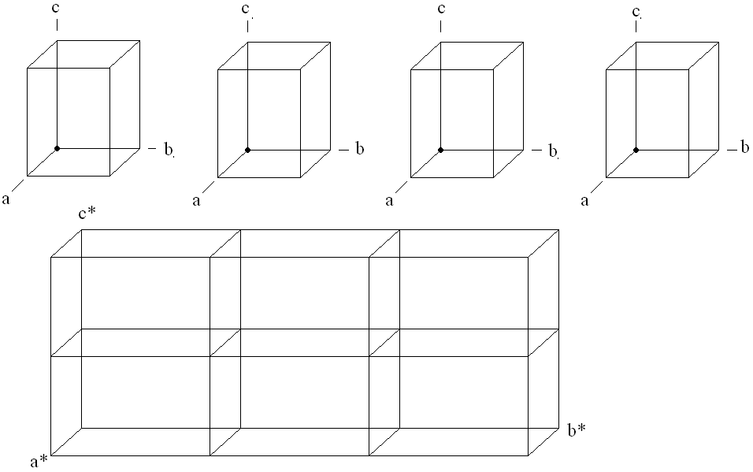

4a. Ewald Sphere, Structure Factors

1. Use the Ewald construction to demonstrate why the Bragg equation cannot be satisfied when d < λ/2. Briefly describe the result of this thought experiment.
2. Use the complex plane to calculate the magnitude and phase angle of the structure
factor F_{c} for a three-atom structure with

|F₁| = 50, φ₁ = 45º (or π/4 radians)
|F₂| = 9, φ₂ = 135º (3π/4 radians)
|F₃| = 15, φ₂ = 0º (0 radians)
For this reflection, draw two parallel hkl planes, and the respective locations of atoms 1, 2, and 3 between these planes.
3. a. For a two-atom structure, calculate the magnitude and phase angle of the reflection hkl = 2 2 -2:
Atom 1: f = 20, coordinates x,y,z = 0.0, 0.0, 0.0
Atom 2: f = 15, coordinates x,y,z = 0.5, 0.5, 0.5

4b. Structure Factors

1. Use the complex plane to calculate the magnitude and phase angle of the structure
factor F_{c} for a three-atom structure with
|F₁| = 30, φ₁ = 30º (or π/3 radians)
|F₂| = 12, φ₂ = 135º (3π/4 radians)
|F₃| = 20, φ₂ = 0º (0 radians)
2. For this reflection, draw the respective locations of atoms 1, 2, and 3 between these hkl planes shown below.
________________________________________________________________________

________________________________________________________________________
3. a. For a two-atom structure, calculate the magnitude and phase angle of the reflection hkl = 2 2 -2:
Atom 1: f = 20, coordinates x,y,z = 0.0, 0.0, 0.5
Atom 2: f = 15, coordinates x,y,z = 0.5, 0.5, 0.5

5a. Symmetry and Space Group

1. The symmetry operation 4₂ always coincides with a collinear 2 operation. Describe why this is the case (an illustration may aid your explanation.
2. The international table of space group #52, Pmna is attached.
a. Describe the meaning of each letter in the title. For symmetry elements, give the name and describe the direction of translation (if applicable):
P-
m-
n-
a-
b. On the attached international table, label the mirror plane symmetry elements on ALL THREE of the setting diagrams (upper left, upper right, and lower left) using an m.
Label the a-glides using an a.
c. In the “symmetry operations” table below the diagrams, label the 2 elements, the 2₁ element, and the inversion center.
d. A 2 axis in the standard setting (upper left) has been marked by me with a *. Indicate the
locations of this same 2 axis by drawing a * in the other two setting diagrams below and to the right.
e. In the multiplicity diagram (lower right), an atom has been indicated by a circle. Circle all other symmetry-equivalent atoms in this diagram which are generated by the 2₁ operations.
f. What is the multiplicity of this cell?
g. What is the multiplicity of an atom on a 2₁ axis?
h. What is the Wyckoff letter of the 2₁ operation?
i. What are the Wyckoff letters of the 1 operations?
¯
j. On the second page of the table, under “reflection conditions,” circle the systematic absence which arises from the 2₁ symmetry.
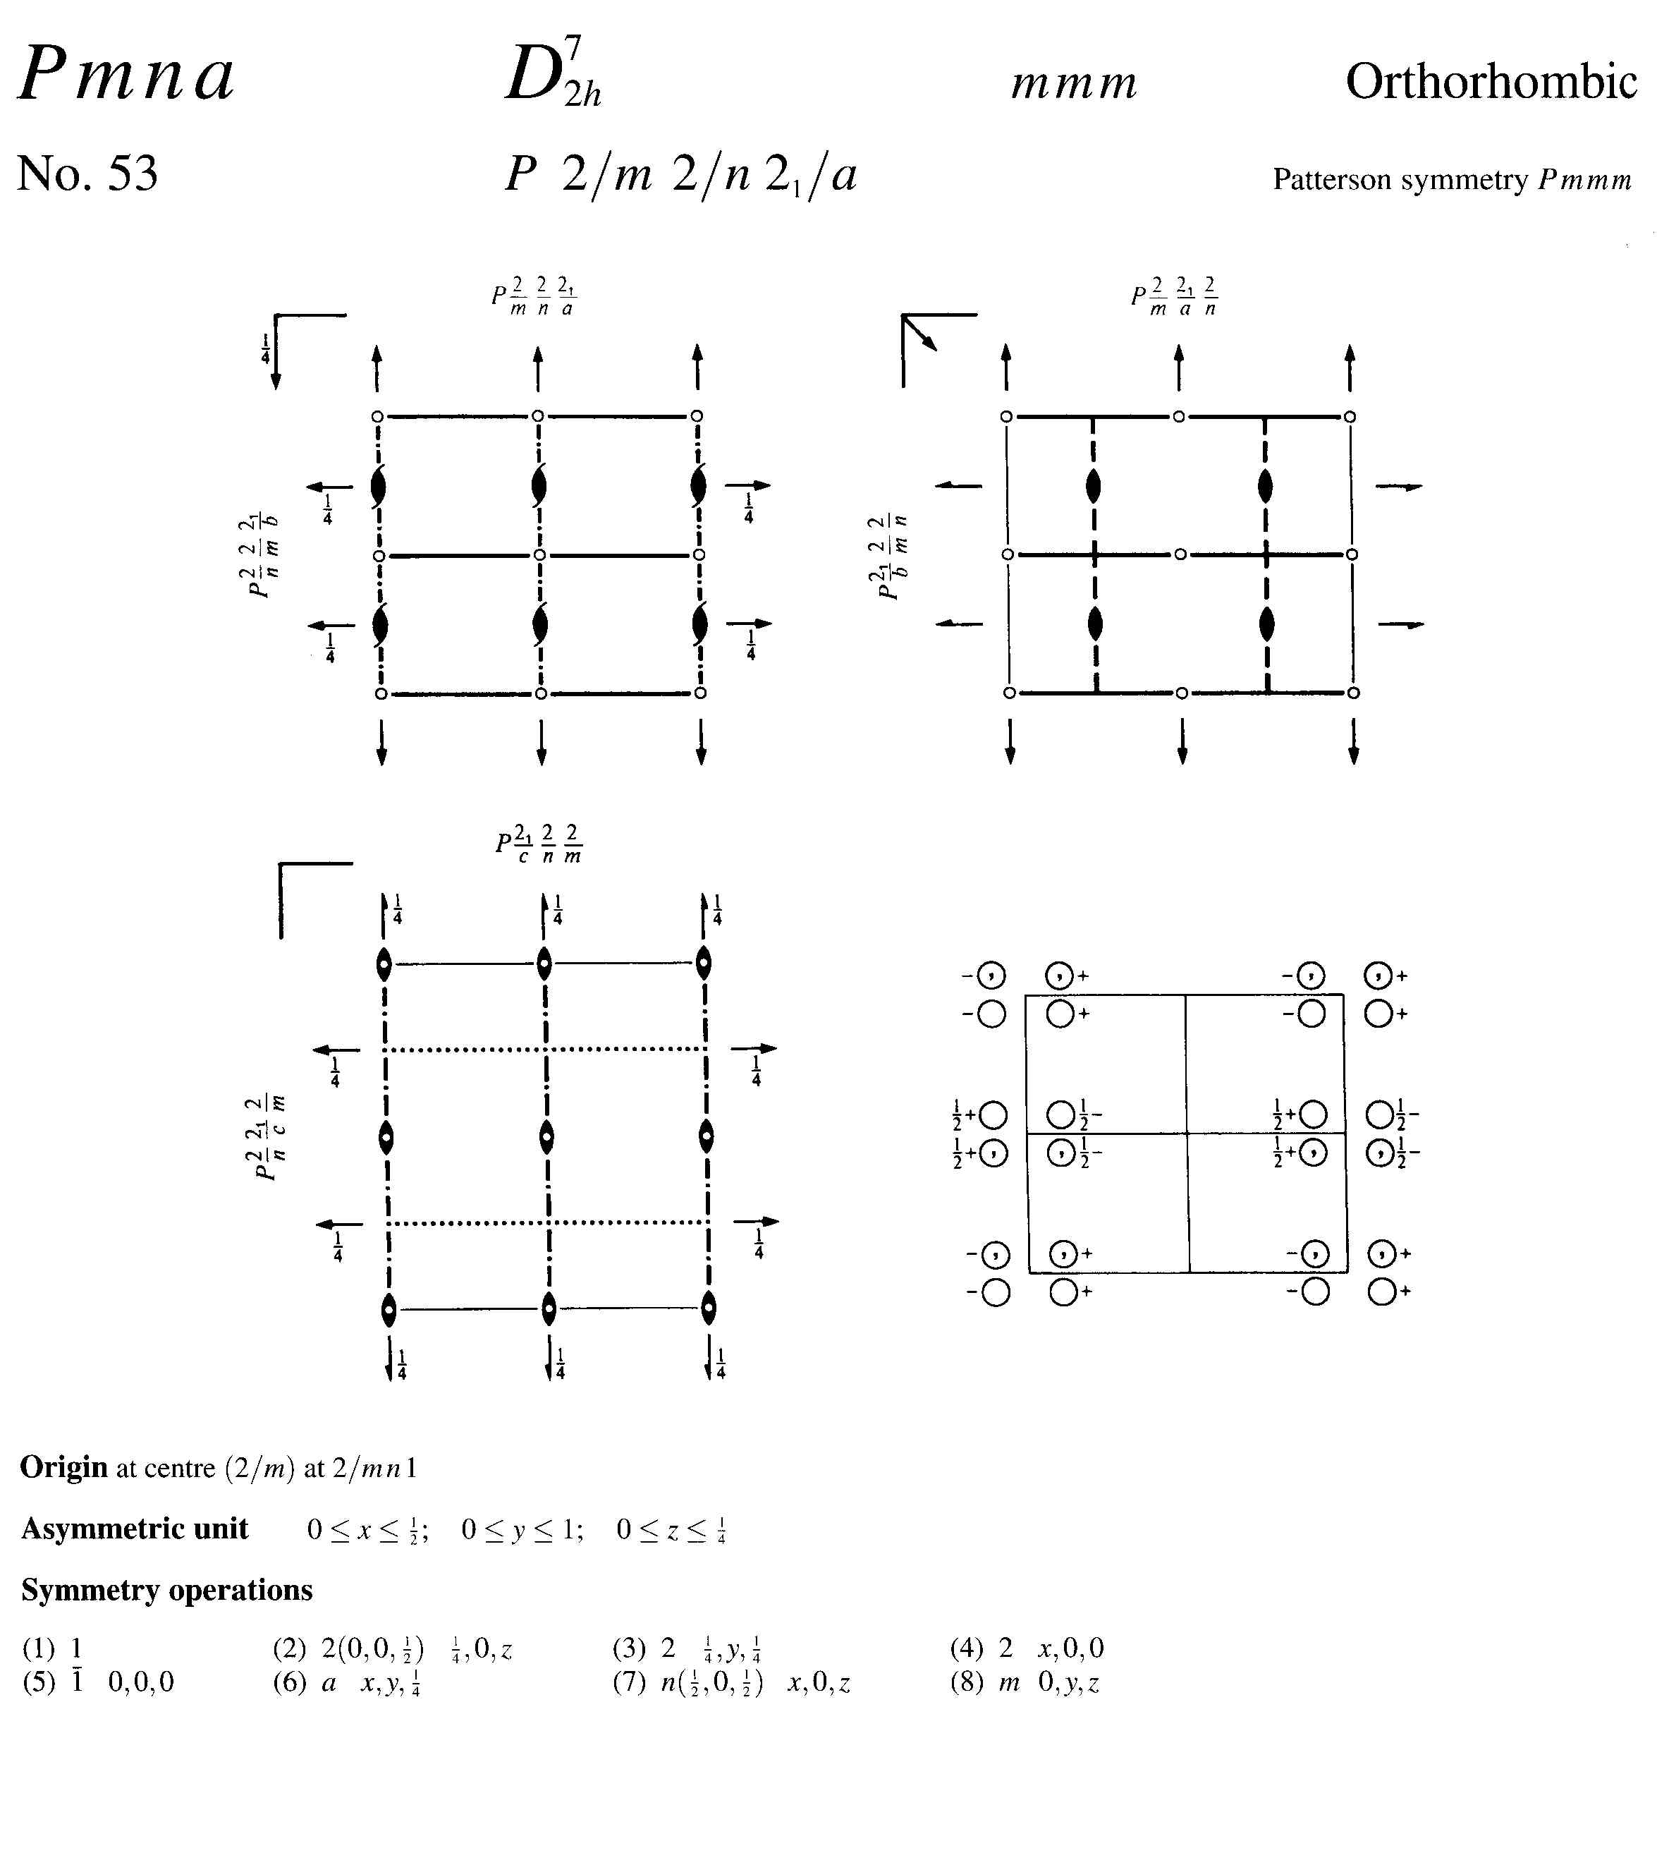
*
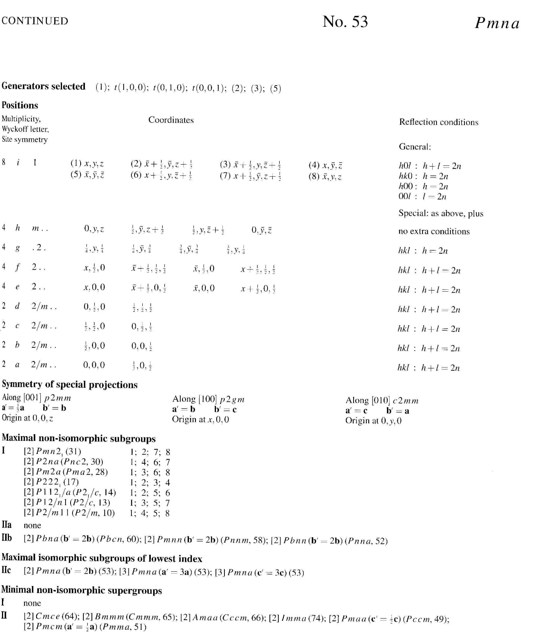

5b. Symmetry and Space Group

1. The symmetry operation 6₃ always coincides with a collinear 3 operation. Describe why this is the case (an illustration may aid your explanation).
2. The international table of space group #52, Pmna is attached.
a. Describe the meaning of each letter in the title. For symmetry elements, give the name and describe the direction of translation (if applicable):
P-
m-
n-
a-
b. On the attached international table, label the 2₁ screw axis symmetry elements on ALL THREE of the setting diagrams (upper left, upper right, and lower left) using an 2₁.
Label the a-glides using an a.
c. In the “symmetry operations” table below the diagrams, label the 2 elements, the 2₁ element, and the inversion center.
d. A m element in the standard setting (upper left) has been marked by me with a *. Indicate the locations of this same m element by drawing a * in the other two setting diagrams below and to the right.
e. In the multiplicity diagram (lower right), an atom has been indicated by a circle. Circle all other symmetry-equivalent atoms in this diagram which are generated by the a operations.
f. What is the multiplicity of this cell?
g. What is the multiplicity of an atom on an m element?
h. What is the Wyckoff letter of the a operation?
i. What are the Wyckoff letters of the 1 operations?
¯
j. On the second page of the table, under “reflection conditions,” circle the systematic absence which arises from the n glide symmetry.
*

6a. Patterson

Use the Patterson method to locate the heavy atoms for the following hypothetical crystal sample in the space group P2₁2₁2:
*

1. What is the “heavy atom” in this structure that we will locate with Patterson methods?
2. Referring to the attached space group table, begin constructing a chart by writing the coordinates for the symmetry equivalents of an atom at xyz along the top header row, and the leftmost header column. (hint, these are the coordinates of an atom in a general position).

3. With the header row and column filled in, begin filling in the table with the uvw coordinates of the Patterson peaks in terms of xyz by subtracting the coordinates of the column header, from the row header (as demonstrated in class).
4. How many patterson peaks can we expect to find for the heavy atom interactions?
5. The largest patterson peaks are listed below.
Peak # intensity u v w
1 999 0 0 0
2. 362 0.101 0.500 0.303
3 356 0.602 0.721 0.000
4. 346 0.500 0.221 0.305
5. 345 0.500 0.221 0.694
From this list of peaks, identify the values of x, y, and z for the iodine atom.
What are the x, y, z coordinates of the other 3 I atoms in the cell?
6. Using the location of these 4 I atoms, approximate the phase of the 213 reflection. Use additional sheets if necessary.

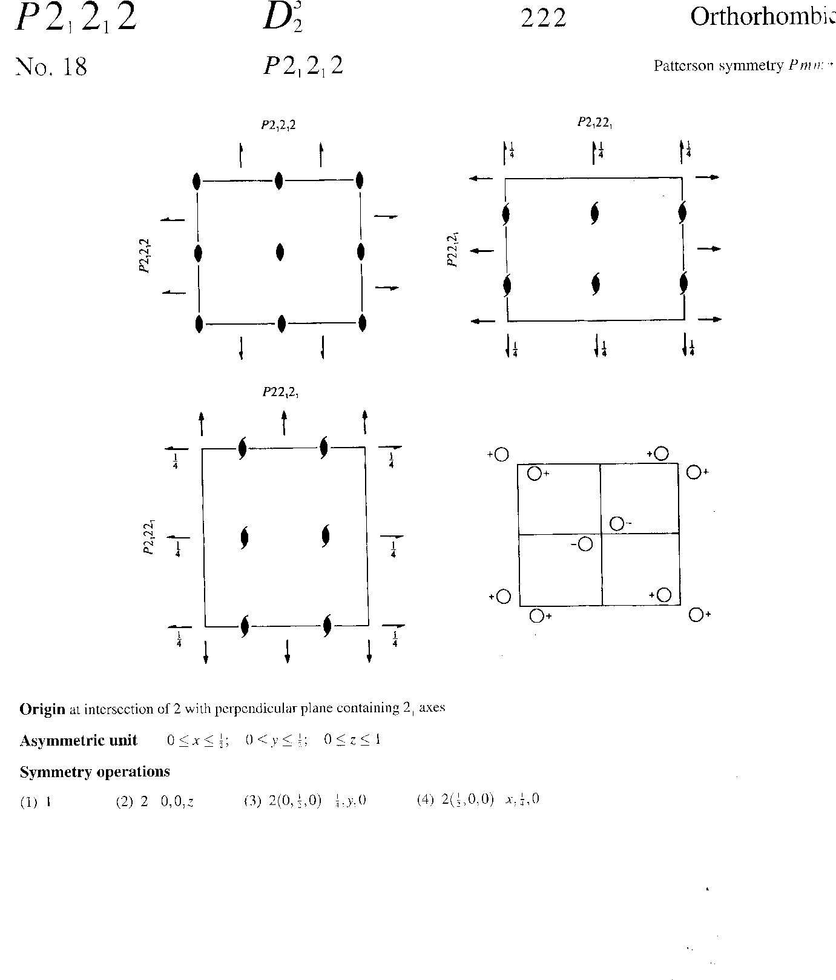
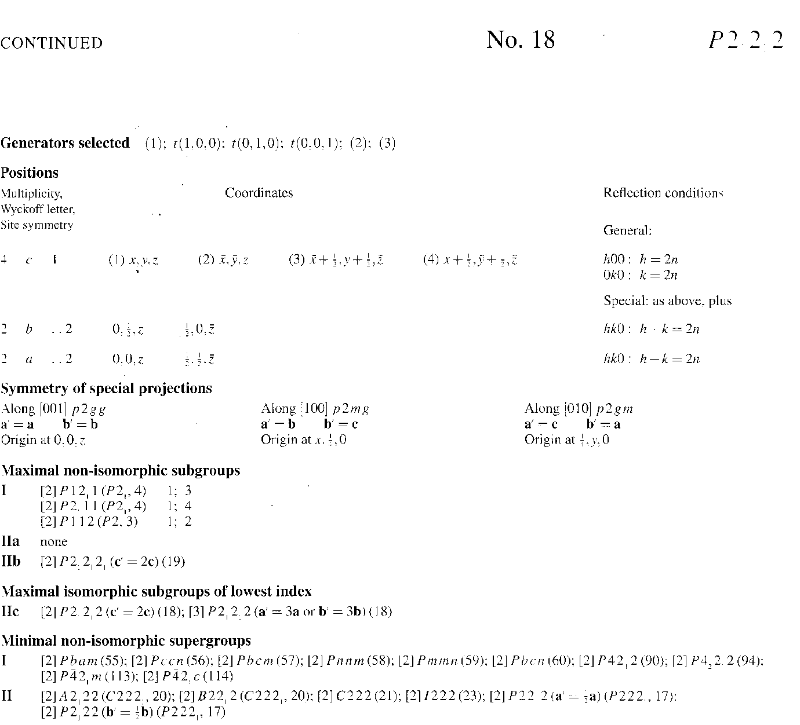

6b. Patterson

Use the Patterson method to locate the heavy atoms for the following hypothetical crystal sample in the space group P2₁2₁2:
1. What is the “heavy atom” in this structure that we will locate with Patterson methods?
2. Referring to the attached space group table, begin constructing a chart by writing the coordinates for the symmetry equivalents of an atom at xyz along the top header row, and the leftmost header column. (hint, these are the coordinates of an atom in a general position).

3. With the header row and column filled in, begin filling in the table with the uvw coordinates of the Patterson peaks in terms of xyz by subtracting the coordinates of the column header, from the row header (as demonstrated in class).
4. How many patterson peaks can we expect to find for the heavy atom interactions?
5. The largest patterson peaks are listed below.
Peak # intensity u v w
1 999 0 0 0
2. 362 0.201 0.500 0.264
3 356 0.701 0.121 0.000
4. 346 0.500 0.621 0.264
5. 345 0.500 0.621 0.736
From this list of peaks, identify the values of x, y, and z for the iodine atom.
What are the x, y, z coordinates of the other 3 I atoms in the cell?
6. Using the location of these 4 I atoms, approximate the phase of the 213 reflection with a structure factor diagram. Use additional sheets if necessary.

6w. Patterson Worksheet
Use the Patterson method to locate the heavy atoms for the following hypothetical crystal sample in the space group P2₁/c Compound: SbPh₃. To use patterson methods, we will determine the location of just the heavy atoms (Sb) in the unit cell.
 | x, y, z | -x,-y,-z | -x, ½ +y, ½ - z | x, ½ - y, ½ + z
x, y, z
-x,-y,-z
-x, ½ +y, ½ - z
x, ½ - y, ½ + z
We will copy coordinates for the general positions of atoms in this space group, using the “positions” table on the attached space group diagram.

With the header row and column filled in, begin filling in the table with the uvw coordinates of the Patterson peaks in terms of xyz by subtracting the coordinates on the side from the ones on top (top – side). Fill in the chart with the coordinates of these differences.
List of peaks in Patterson space (from computer: FS without phases).
No height u v w assignment
1 --- 0 0 0
2 999 0.166 0.500 0.457
3 964 0.000 0.250 0.500
4 447 0.166 0.250 0.957
Use the back of this sheet for scratchwork in calculating x, y, and z.
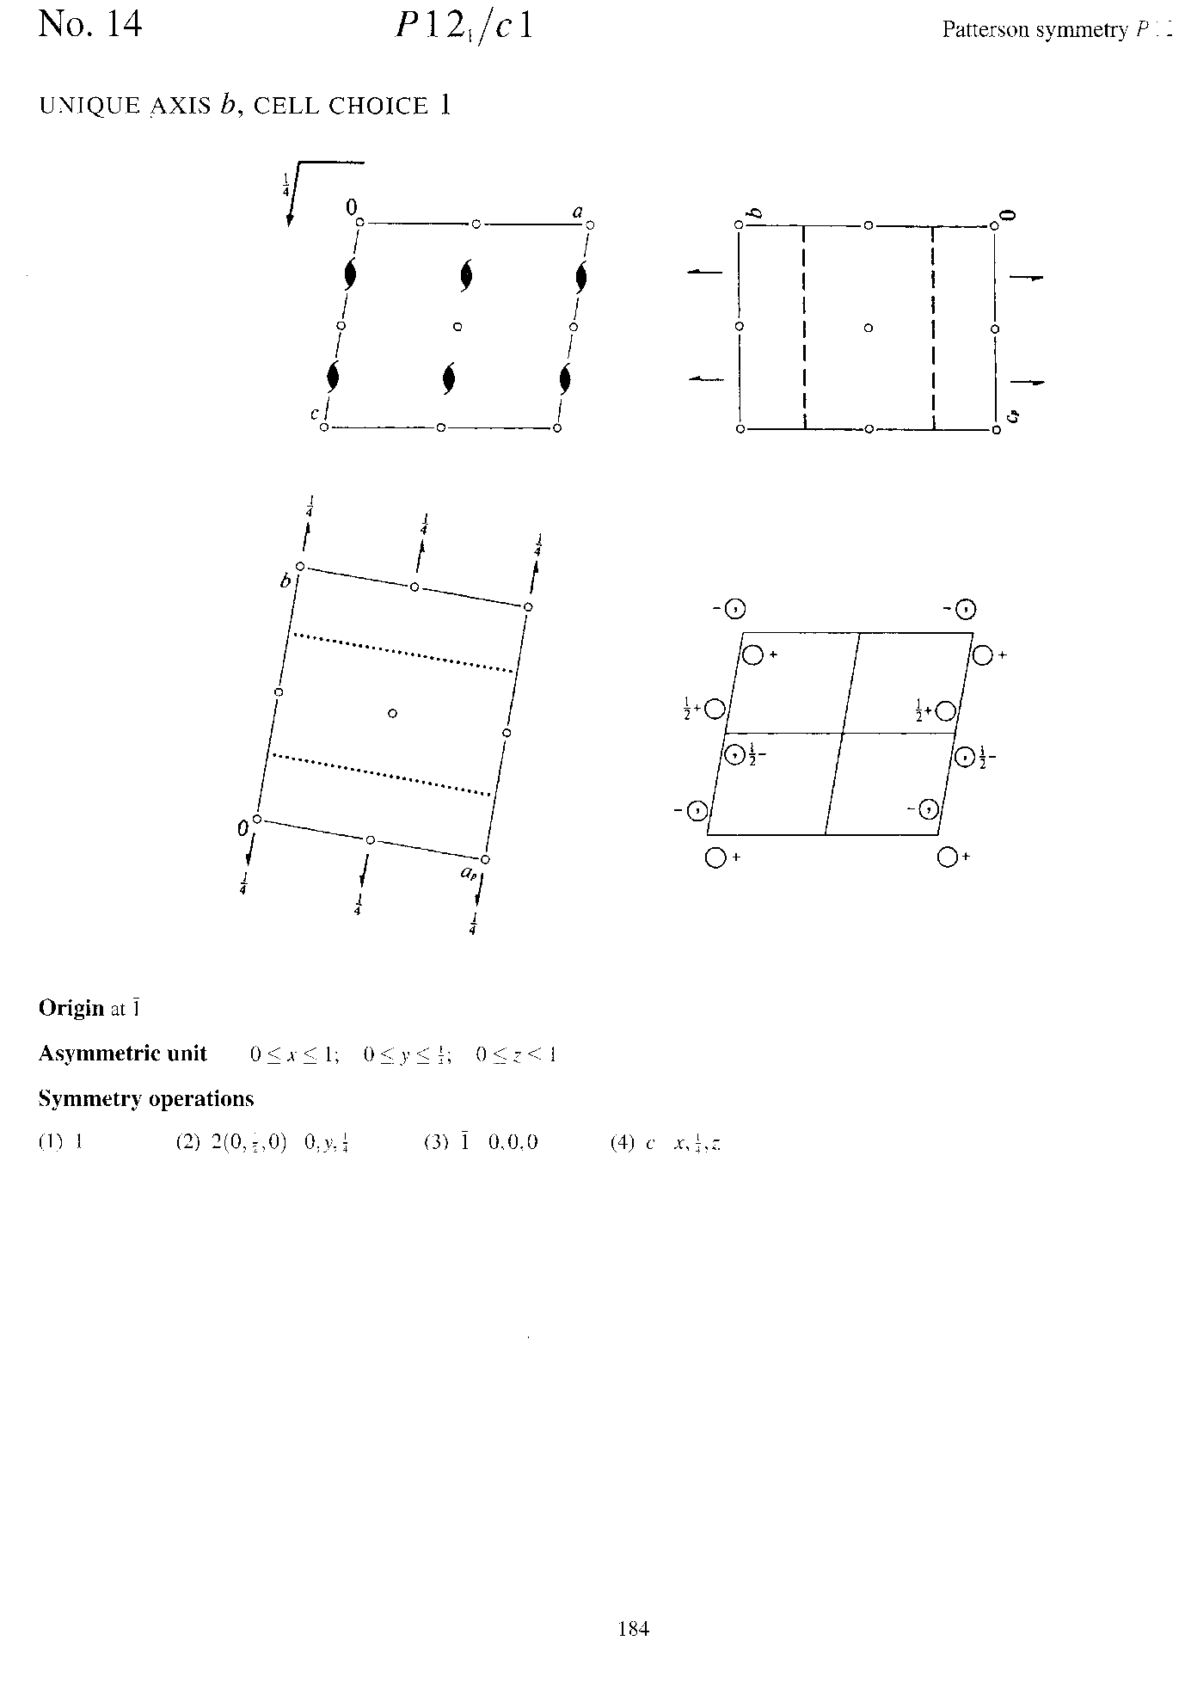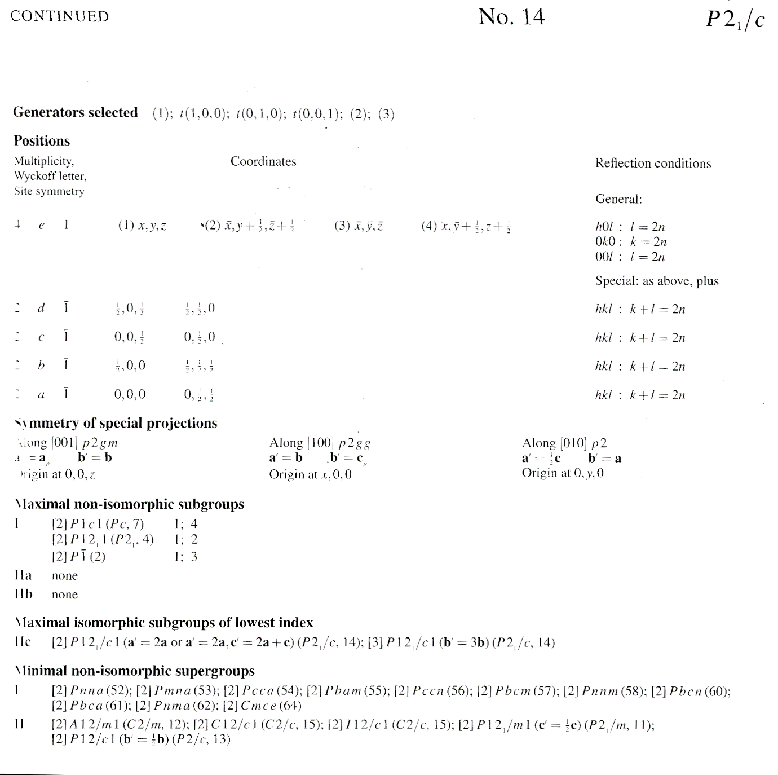
P2₁/c

7. Direct Methods

Use direct methods to determine the phase angles for the following centrosymmetric hypothetical “mini” data set. In this data set, the brightest 8 spots are listed below. Assume for this exercise than ANY spot not listed is WEAK.
E₁₀₀ E₂₀₀ E₀₂₀ E₀₀₂ E₀₄₀ E₀₀₄ E₁₂₁ E₂₄₂ E₂₄₄
Using these spots, determine the phases of as many spots as possible.
1. Identify the quartet relationship (there is only one) and write it below.
2. Determine whether this is a positive or negative quartet (remember, any spot NOT LISTED above is to be assumed weak).
3. Write the Σ₂ relationship below (there is only one)
4. Write the Σ₂ relationships below (there are 4).
5. Assign phases to as many peaks as possible. You may do this by writing them in the above expressions in parenthesis, or list them here.
6. Are there any reflections for which you cannot assign phases? Which?

8a. Disorder, Anomalous Dispersion

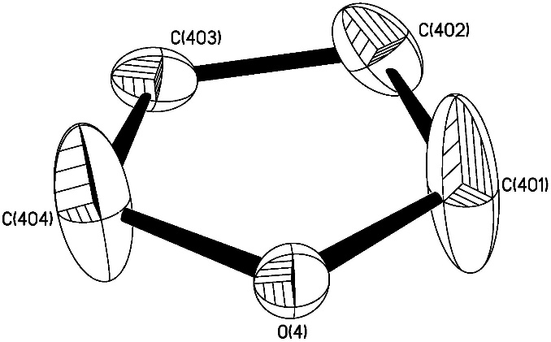
1. Consider above model of a THF molecule. Below is given the atom formfactor adjustment equation for anisotropic vibration:
-2π(U₁₁h²a*² + U₂₂k²b*² + U₃₃l²c*² + 2U₂₃klb*c* + 2U₁₃hla*c* +2U₁₂hka*b*)
f’ = fe
a. Qualitatively describe the thermal parameters of C(401) and C(404). Be specific in terms of whether you are talking about U_{ii} or U_{ij.}
b. If these thermal parameters are a result of vibration, what effect do these highly vibrating atoms have on the data (hint, refer to the equation above)?
c. If these thermal parameters are due to disorder, how you could treat the disorder of this THF molecule to make your model more accurate?
d. How would you determine which model (vibration vs. disorder) was the best model for your structure?
2. For a hypothetical structure with the following atom coordinates and form factor values:
Atom name x y z f’ Δf’ Δf”
C1 0.125 0.000 0.890 5 0.018 0.009
N1 0.000 0.000 0.218 6 0.031 0.018
Co1 0.450 0.250 0.659 25 -2.365 3.614
Use the space below to construct a structure factor diagram for F₁₁₀ in the complex plane IGNORING anomalous scattering. Please make your vector lengths and angles as accurate as possible.
Use the space below to construct a structure factor diagram for F₁₁₀ in the complex plane INCLUDING anomalous scattering. Please make your vector lengths and angles as accurate as possible.

8b. Disorder, Weighting, Anomalous Dispersion, Quasicrystals

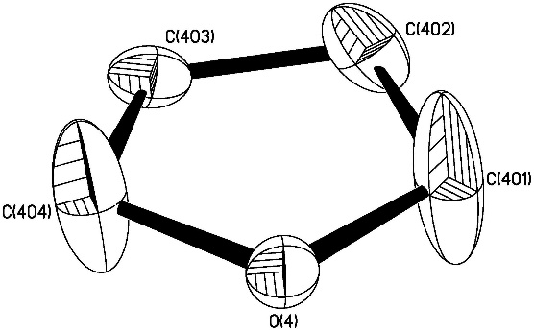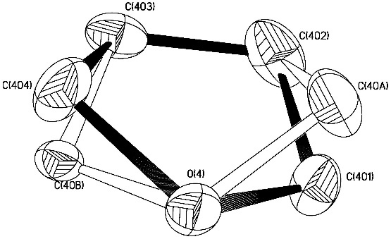
1. Consider the two models above of a disordered THF molecule. The left model is the result of refinement against a single-site model, and the right model is the result of refinement against a two-site disorder model. Below is given the atom formfactor adjustment equation for anisotropic vibration:
-2π(U₁₁h²a*² + U₂₂k²b*² + U₃₃l²c*² + 2U₂₃klb*c* + 2U₁₃hla*c* +2U₁₂hka*b*)
f’ = fe
a. The model on the left is a model with C404 and C401 vibrating. Describe qualitatively the values of U_{ii} and U_{ij.}
b. The model on the right is a two-site disorder model. Describe qualitatively the values of U_{ii} and U_{ij.} in this model.
c. Considering the F_{calc} values from these two models, how will the calculated reciprocal lattice differ? Where in the reciprocal lattice will these differences be most significant.
d. How do we decide which model is best experimentally?
2. Consider the simple weighting scheme:
1
σ
w =
where s is the relative % uncertainty in peak integral. Shown below are cross sections of a few reflections as integrated on the instrument detector. For these pairs of reflections, circle the reflection which will be weighted more heavily in the least squares analysis.
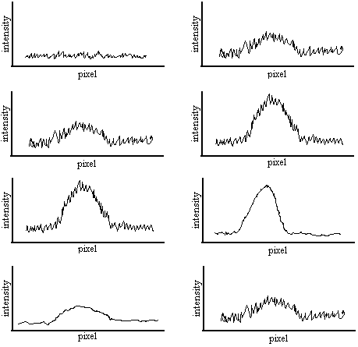
a

b

c

d

3. Which of the following diffraction patterns exhibits crystallographically forbidden symmetry consistent with a quasicrystal? Circle those that apply, and give the symmetry element. (Yes, these are REAL diffraction patterns!)

a. b.
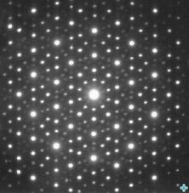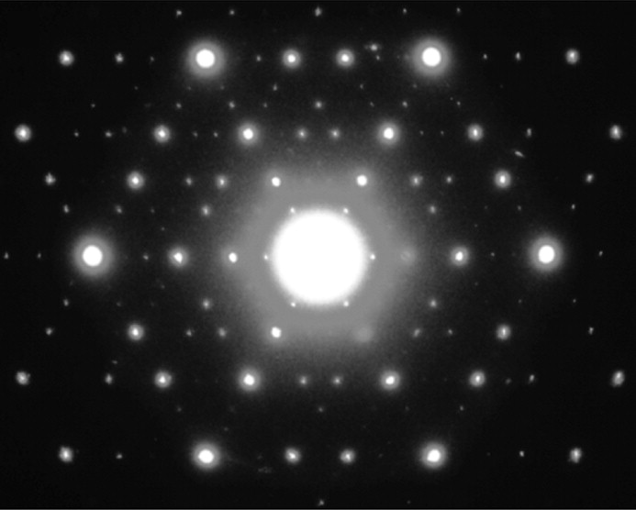

c. d.
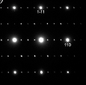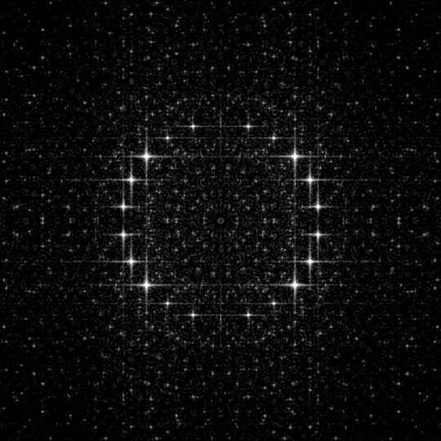

4. For a hypothetical structure with the following atom coordinates and form factor values:
Atom name x y z f’ Δf’ Δf”
C1 0.125 0.000 0.100 11 -0.020 0.001
N1 0.000 0.000 0.500 12 -0.021 0.001
Cl1 0.450 0.250 0.750 46 -6.000 2.000
Use the space below to construct a structure factor diagram for F₀₁₁ in the complex plane IGNORING anomalous scattering. Please make your vector lengths and angles as accurate as possible.
Use the space below to construct a structure factor diagram for F₀₁₁ in the complex plane INCLUDING anomalous scattering. Please make your vector lengths and angles as accurate as possible.
Does the inclusion of anomalous scattering increase or decrease the value of F₀₁₁?

9. Anomalous Dispersion, Twinning

1. For a hypothetical structure with the following atom coordinates and form factor values:
Atom name x y z f’ Δf’ Δf”
C1 0.625 0.000 0.890 6 -0.018 0.009
N1 0.000 0.000 0.518 7 -0.031 0.018
Co1 0.150 0.250 0.259 27 -2.164 1.614
Use the space below to construct a structure factor diagram for F₁₁₀ in the complex plane IGNORING anomalous scattering. Please make your vector lengths and angles as accurate as possible.
Use the space below to construct a structure factor diagram for F₁₁₀ in the complex plane INCLUDING anomalous scattering. Please make your vector lengths and angles as accurate as possible.
2. Consider the following twin laws for a tetragonal cell. Please describe the operation this twin law describes and its orientation (e.g. “two-fold rotation about the a axis” or some such), and classify each of the following twin laws as racemic, merohedral, non-merohedral, or pseudomerohedral.

-1 0 0 -1 0 0 0 1 0 0 0 -1 1 0 0
0 -1 0 0 -1 0 -1 0 0 0 1 0 0 -1 0
0 0 -1 0 0 1 0 0 1 1 0 0 0 0 -1

Element: ________ __________ ________ ________ __________

Oriented: ________ __________ ________ ________ __________

Type: ________ __________ ________ ________ __________
(mero-,
non-mero-,
pseudomerohedral)

