A Guide on How to Set up and Run a “Lego of my Medicine” Activity
Table of Contents
General comments and goals of the activity 2
Set up of the resources. 2
Things to buy 2
The Lego 2
Things to print 2
Things to make 2
Making a model 3
With Lego 3
With 3D printer 5
Lego bags 5
Other resources 6
The actual session 7
Scoring/assay runner/biologist 7
Chemist/Walking round helper 8
Ending 9
Alternations possible and contact details 10
Cheaper options 10
Molymods 10
Younger audience. 10

General comments and goals of the activity
Hello!
I am Alex Derry, and I gratefully received a grant from the CCDC to bring this project to life. I originally had this idea in my undergrad and used as an idea in my PhD interview. This is a document that hopefully provides all the information you need. If you need anything extra after reading this, or find any errors/improvements, feel free to contact me at my work email: umaed@leeds.ac.uk. I am a PhD student so this will likely not be active after 2026 when I finish. I may update it before then to give a new email address.
I, with the help of many other colleagues at the University of Leeds, have spent a lot of time to make this activity interesting and fun. We have tried stuff out and fixed some stuff, but there is always room for improvement. Huge thank you to Becca Motley and Emily Caseley for coming into schools and helping out in general stuff. Alex Snow for helping with the 3D printing. Also, for the Fishwick group in chemistry for being guinea pigs for testing in the early stages and all the others who helped out with ideas early on.
This activity should cost ~£120 - £200 depending on if you have a 3D printer and what you get.
The document here is quite long, but covers a lot of the things you need, so please take the time to read it fully.

Set up of the resources.

Things to buy

The Lego
- You need 2 boxes of the “lots of Bricks” (lot number 11030) (https://www.lego.com/en-gb/product/lots-of-bricks-11030) This will give 200 bricks of each colour. You will need to buy another box too for building the pocket if you want. Or you can try and source this elsewhere. They sell for ~£55 each.
- Zip lock bags to put the Lego in. Something like £3.
- Barrier or box to hide the pocket while the assay is being run (the Lego might be delivered in something like this
- Prizes. I used Lego keyrings. On eBay these are about £1.20 each

Things to print.
- The money document.
- Any slides you want on hand when walking round.
- The handout document with tips on the back (print flip on short side)
- The crystal structures 1 and 2 and coloured 1 and 2 and the extra hits 1 and 2

Things to make.
- The bag of 200 Lego of one colour (all but black and white) x6
- The pocket
- The final compound
- The initial hit x6 (in black and white)
- Extra bags of 100 Lego (in black and white)
- The mini model of an example pocket (see PowerPoint)

Making a model
I have made this module in the image of salbutamol, the drug often used in inhalers. This is because of a few reasons.
- It is a relatively simple structure, and a good shape and size for the task. Not too many hetro atoms (Nitrogen, oxygen etc.), but enough to make a point of it as a learning exercise.
- It is not something that students will directly know the shape and structure of, which they might find with aspirin or paracetamol.
- However, it is something they will know of with its relation to asthma. I suspect at least someone in the class has an inhaler or knows someone with one.
When building it I tired to make it true to the original crystal structure I found on the Protein data back (PDB). One brick as an atom, one as a bond, then another as another atom is a rough guide (although trying to make a hexagon/benzene with Lego was an interesting challenge). I also included some thinner 1x4 bricks to make getting the last couple of bricks tricky, so students don’t finish early.

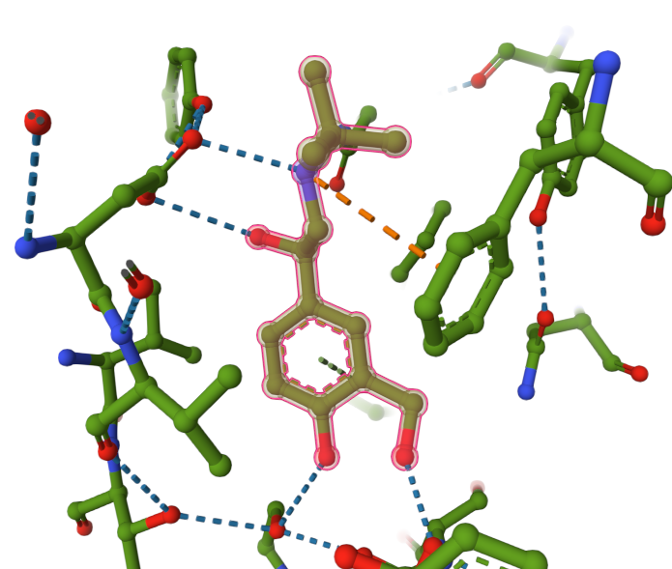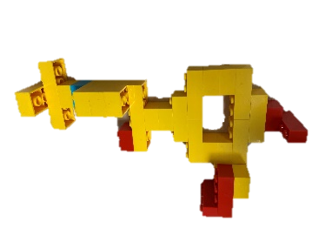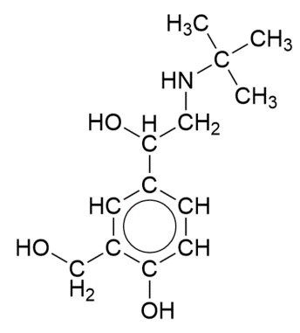
If you want to make changes to the structure or do a completely different structure, feel free to. This activity is meant to suit your needs and has room for improvements and changes. I suggest if you want to change the structure, you have a think about the things above in the numbered list and consider the difficulty of the task you want to make. This was made for year 12 students.
Build the molecule first before the pocket. This example should take.
Brick type | Number of bricks in salbutamol module
2x2 | 7
4x2 | 11
6x2 | 2
2x4 blue | 1
2x2 red | 2
2x1 red | 2
Note, Lego nomenclature. Stud is a single dot on the top of a brick. 2x4 means a brick 2 studs by 4 studs, which is a “normal” brick.
You will also need to make the pocket. There are 2 ways to do this:

With Lego
The model I have build is a bit of a prototype that has just survived and worked for a while, with me lacking the energy to remake and improve it. Due to how Lego is made, making a gap with Lego is hard and you need to use thin plate like bricks to stack up to make a snug fit. These don’t come in the “lots of Bricks” box sold by Lego. Also, if you are using all the bricks from those sets for the activity, you wont have any left for the model.
I ended up using about 100 of the brown bricks (one “lots of bricks” set) and got the flatter bricks from eBay with buying a 1kg random assortment of bricks. This had a lot of handy pieces for making the model. Obviously, this is random, so if you do this method, you may not get the same results, but I suspect it will be ok. This cost me £12.50 for the 1 kg. This also came with some flat smooth pieces, which were great for putting in the pocket to allow the molecule to slide in and out easier. I have included pictures below of my model, if you wish to recreate it to its true likeness. Having different colours through the pocket that are greys and blacks, helps make the crystal structure have some more difficulty in its interpretation and also pushes students to get the coloured versions.
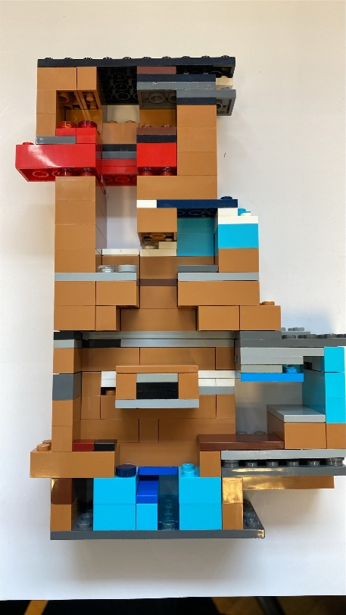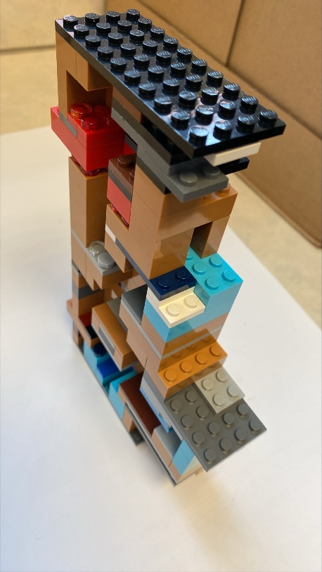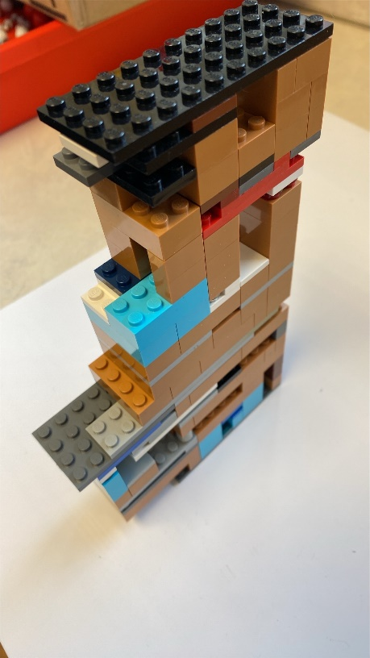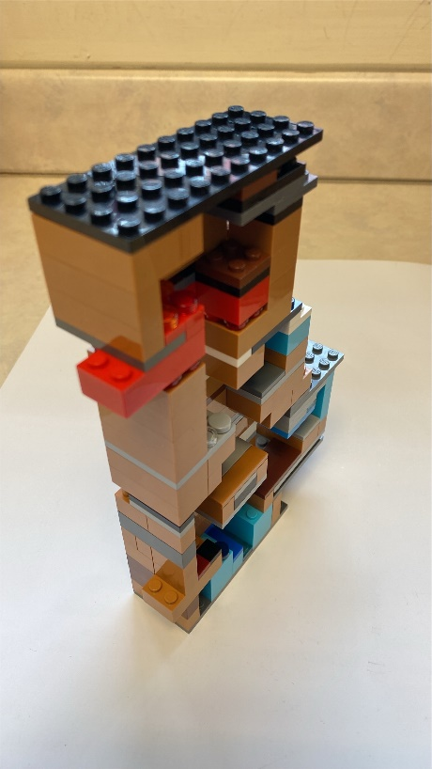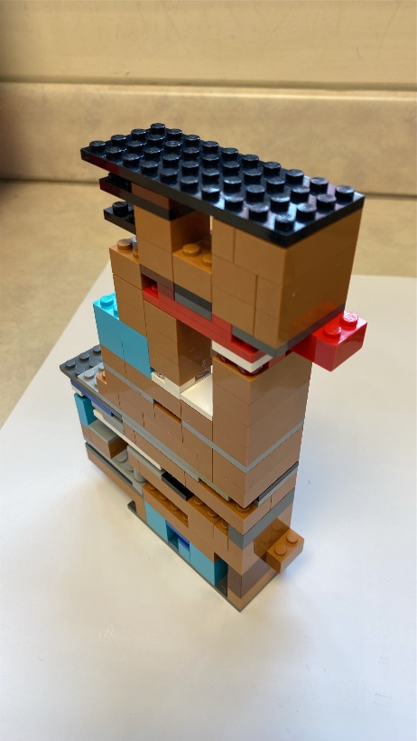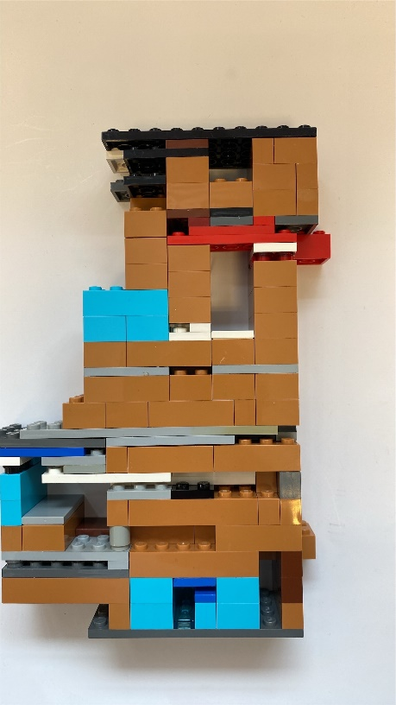
If you make a new model, you may need to recreate the crystal structures so bare that in mind.

With 3D printer
There should be with this guide a 3D model of the salbutamol and one of the pockets. You will need a plain colour a red and a blue colour for the extra interactions. We tried printing it, although had some issues, so I can’t guarantee its perfect. We will try again and may update this when we know more.
If you want to make your own model. I recommend either building your molecule and then measuring or using a computer program to make the model and import it into a 3D printing program to make a pocket around it. I used a program called Studio 2.0, which seems like a common one for Lego enthusiasts. We exported it as Collada, although use whatever works for you.
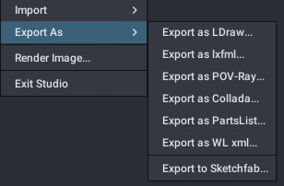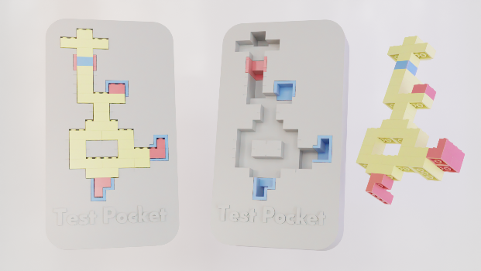
I also recommend making the pocket a little bigger than the ligand, to let it fit in and out and leave some holes at the back to allow the assay runner to push the tested molecules back out when running assays. I also recommend little notches or marks on the pocket to indicate where the bricks are, to make counting much easier for assay runners.
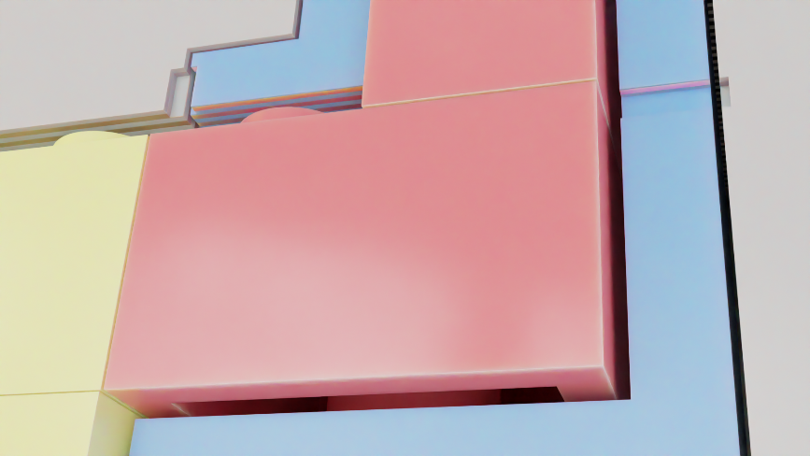

Lego bags
I have used resealable bags to contain the bricks, ideally the large size to mean it is easier to seal as the medium ones were a little tight. In each I have combined 2 of the “lots of bricks” and have put all of one colour in the bag. I stacked these up in the counting process to make it a little easier
Hence each bag should have
- 40 2x1
- 40 2x2
- 16 1x4
- 64 2x4
- 8 2x6
- I often omitted the 1x1 bricks (so its technically its only 168 bricks) but these bricks are kind of pointless in the kit.
I then added a portion of the red and blue bricks. Although they only need one blue brick and more red bricks, I included an equal amount to mean that there was no preference to one or the other. I added for the 6 kits 1/6th of the remaining red bricks I had after building the pocket. In this case it was for red and for blue individually,
- 6 of 2x1
- 7 of 2x2
- 3 of 1x4
- 10 of 2x4
- 1 of 2x6
Main thing is they have enough to make 2 models with the colours they have. We never had anyone buy the extra 100 bricks on the activity. This may be because people felt like they had plenty. In the testing phase, when we had only 100 bricks (one set of the lots of bricks) they bought the extra bricks, so if you are on a budget or have smaller teams, it definitely could be worth trying to include less of the default colour bricks (like 100 instead of 200)
I also would add the money (£1000 in the little notes paperclipped together), the help guide, and possible the hit model in black or white. I would probably advise taking the hit to them directly rather than in the bag as it can often break and they may not put it back together correctly.

Other resources
There are things the students can buy to improve their chances at getting the final structure. I highly recommend printing out the money (again a sheet of which should be included with this kit). The colours help to distinguish 200 and 20s. They are also in the style of Lego Money notes to add to Lego theme! There is also crystal structure pictures and fragments. The crystal structure pictures are as the ones on the PowerPoint. These I took a picture of the Lego pocket and then used tools in PowerPoint to alter how they look to give the impression of bad resolution. Click on picture format on the top row on PowerPoint and then go to Artistic Effects. Further altering the picture with a right click and format picture will allow altering of the intensity of the effect. I found taking the picture further away for smaller models (as seen below) worked better. Add greyscale later.
The other “hits” are different to those on the board. Feel free to laminate any of these things if you have the time/facilities. We didn’t and it worked fine, although some of the crystal structures got drawn on, which is fine.
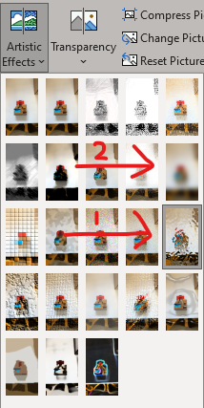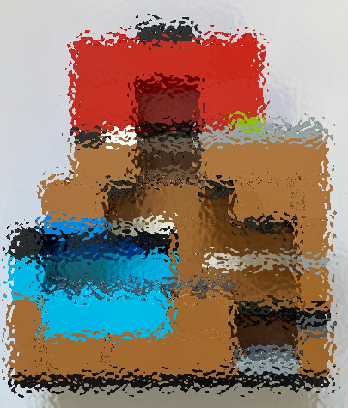

The actual session
This should be about 1.5-2h long and can vary with the time you spend at the start intro and between each new update. For the 2-hour session, we spent about 15-20 min on the intro and asked students to submit their last assay runs 15 min before the end. Then around every 15-20 min gave an update by halting everyone and moving the slide on, to bring their attention to new information. This is a driving force to mean that those who don’t buy the crystal structure, are not drastically disadvantaged as it seems to be the most popular option for people to buy. (It is arguably the best one too, although people are a bit frustrated when they find out they bought something that everyone has access too so has its pros and cons). You can hint at this coming if you want, but you can also leave it to a surprise. We left it as a surprise as it was to simulate the real world and others collaborating and the race to the commercialised drug.
When the extra fragment comes up, hint to those struggling to combine the structures. This is to get them to make the ring, which helps with the fragility of the Lego model, and assists with a third ionic interaction.
You will need a minimum of 2 people to run the session. The more the better. If you have the ability to, try to have someone near/at the assay station to run the assays when students need them. I recommend a box or some barrier to stop the students seeing the final pocket. I also recommend having the correct structure next to it to check it against if you need to. Be careful, the molecules are fragile, particularly in the middle part. Feel free to reinforce this if you make your own, although will loose a bit of the “original drug” aspect.

Scoring/assay runner/biologist
This can be a tough job and needs to ideally be consistent. Keep an excel sheet open of the scores. You can do one per team, or just score as needed. Scoring is done in the “running” of the assay. I needed a way to quantify how good or bad a molecule was compared to others. It needed to be quick and relatively simple, while also covering some basic medicinal chemistry. As a result, I have used this scoring method below. This means the perfect molecule (which there are multiple answers for in where the ionic interactions are placed) will have a score of 0, which is similar how we want high affinity of drug molecules to proteins. In the sessions we have run, students have got down to 16-4 range for the winning team. Other teams stuck around the 60-80 mark at the upper end of the range of students. They often made gradual progress, with it often being slow at the start.
The ionic interactions refer to the red and blue colours. They need to be opposite, as if they were a magnet (red-blue) for a good interaction. The salbutamol has 4 of these, with 2 being shown at the start. Any that are not used, have a penalty of +20. If the ionic colours are wrong (red-red, blue-blue) then this means a jump in the score by +40. The space “not filled” is the main counting task. Count per 2x2 brick (square). The 2x4 are obviously 2 of these 2x2 bricks. Each 2x2 is +4 penalty. Have a few practice runs before running it in the lesson. The final penalty is the overfilled space. This is to prevent students growing out of the pocket. In drug discovery, this could be to improve solubility etc. but here isn’t as applicable and a bit too advanced, so can use the excuse of the pocket having a lid that closes.
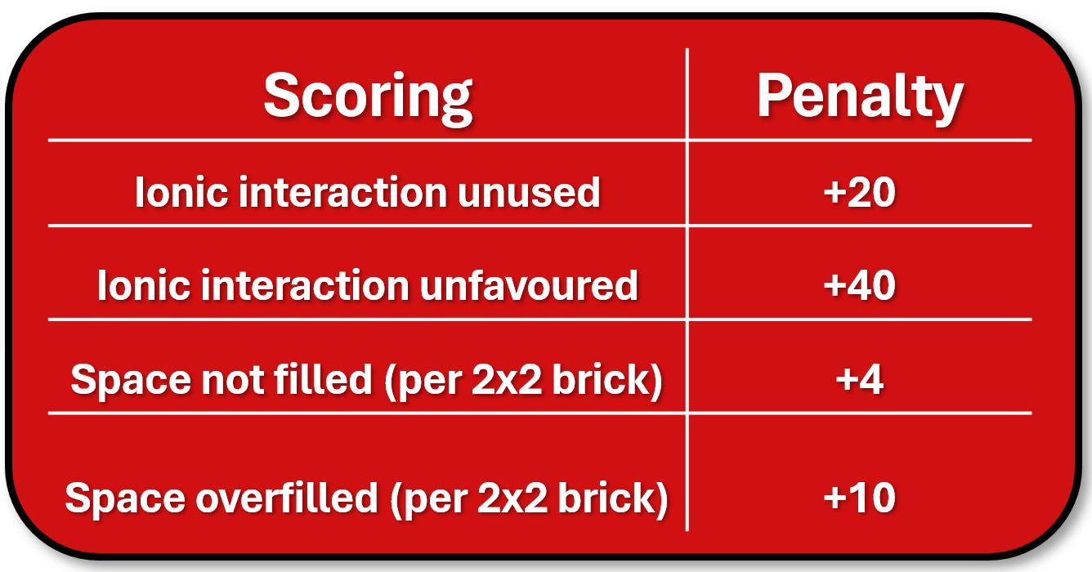

Here are some tips for the counting of spaces and scoring.
- Start at the bottom and work your way up.
- Try checking the back first, as this can be easily hiding some missing parts.
- The top part of the shaft (top of the molecule) is confusing to count but use the final compound as a good example to reference.
- Don’t forget the 1x4 at the bottom and the side. They also count as the same space as a 2x2 (4 studs), so should make counting easier.
- If they fill a 2x1 space, count as a half. (e.g. 3.5)
- If it doesn’t fit, don’t feel bad to reject it.
- Keep an eye out for new red and blue bricks, as they can often be missed.
- To count for the ionic interactions, it needs to touch the blue/red part pocket.
- Main thing is if you are unsure, be consistent.
- There are 44 spaces filled by the perfect molecule.
This being said, the vast majority of students attempts (about 75%) won’t fit in the pocket. Students will often add too much, particularly at the start of the task, and so you will end up rejecting it saying it doesn’t fit. They will learn a lot from failed attempts as much as they would with one that works. Ideally, they should be adding 1-3 bricks at a time. Think general scientific testing, if you change too many things you don’t know what made a difference.
Feel free, depending on the time left in the session and their progress, to give hints at your discretion. Gentle reminders of the original hints they get, such as making a ring and small incremental changes (like one or 2 bricks at a time) as the groups that follow these often do well. Also hints at where there are issues. Refer them to the updates on the board, with the hit(s). Remind them the hit definitely fits in the pocket. A final hint can be to tell them areas that are fine, and the rough areas that are causing clashes/preventing fitting in the pocket.
If you can get a second pocket made up, as means you can run 2 at a time, that would help. We often found a bottle neck in the task with just the one pocket. Not required but definitely helps.

Chemist/Walking round helper
Be proactive and talk to groups. This ideally is someone with chemistry knowledge. Have an idea of the final structure, either in your mind or on some paper, so you are pushing them in the right direction. The initial part will have people make the hit with their colour bricks and then building from this. The majority of people will add way too much way too quickly. I have seen people make a whole other ring than the one intended from the shaft area. You will be saying “small incremental changes” regularly. This is 1 or 2 bricks at a time, then test. Remind the students to make notes of what they have made/what works. Phones to take pictures is the easiest way. A whiteboard is also handy, or good old pen and paper. Also praise keeping the hit intact as a reference and ideally their best molecule. They have plenty of bricks and so can do this easily.
I recommend keeping the original hit intact. They should be given this at the start, and I have done this with the black and white bricks, to make sure they don’t dismantle it. It will break and you will need to re fix it, so they don’t go on the wrong structure. If you give the 100 extra bricks, use the colour different to the mini hit models, so they don’t dismantle it.
Some students will be really engaged with the activity. Working as a team and rallying around trying to get the best score. There will also be those who kind of just sit and chat and play with the Lego. This is somewhat inevitable. Try to engage these students. Some teams may have one person not engaged as it can be hard with a group of 4/5 when everyone is contributing ideas. Maybe suggest roles they can be a part of such as recording or building duplicate models, so modifications are easier. Or they can take a more creative side and come up with a pharmaceutical company name/logo/tag line.
I recommend taking some printouts of some of the key slides from the intro, explaining the electronic and steric interactions. I also found using a smaller version of the model (not the actual shape but an example as seen on the PowerPoint easier slides). This was very useful in explaining the idea that they were given an incomplete molecule and need to add stuff to complete it. Take parts of the mini model and show them visually holes and adding to the hit fills those to get a better score.

Ending
At the end, I recommend giving them a clear warning of how long they have left. E.g. a 10 min warning to submit samples. Show them the final structure and praise all. It is trial and error at the end of the day and sometimes you get lucky with your choices and other times you don’t. If you want, I think it would be helpful to let them have a feel for how it fit and compare theirs.
If you want to incentivise participation, I suggest buying some Lego keychains. Lego sell these but are much more expensive than can be found on eBay. The ones I found were ~1.50 per brick keychain for a 2x4 brick. I got a selection of colours to allow winners to choose.

Alternations possible and contact details
We have run this activity a couple of times now, and it works well. That doesn’t mean its perfect and there are some things that I think could do with improving, in addition to places that if you wanted to make it a bit more interesting you definitely could make some changes due to time or money constraints, or to make it applicable for a younger audience. I will list some of my ideas below. If you try these out and they work well or you have other general comments, please feel free to email me at, umaed@leeds.ac.uk – (will not work after 2026 when I plan to graduate) I have enjoyed making this and would love to hear any changes or recommendations you have to make it a better activity for the community.

Cheaper options
I mentioned in the building the bags section that you can use less, and this may incentivise buying the 100 extra bricks more. Hence you would only need to get one set of the “lots of bricks”. If you have Lego already, you can try to use that instead. You may also be able to get off brand Lego. I would not recommend the 1 kg bags for all the Lego as don’t think you will get enough consistency to get enough bricks.

Molymods
If you want to make it a bit less Lego based and more on chemical structures, then you can try using Molymods, or similar. This will mean you need to figure out how to make a new pocket and score it in some way.

Younger audience.
I have aimed this activity at Sixth formers. I think it could work for students as low as year 10 (15 years old). However, I don’t know of a way to easily convert the project to a lower year group. If you are able to please feel free to let me know.
I think once you get to the lower year groups you have more people just play with the Lego, which is already a minor issue for the Year 12s I have done it with. I also think they need some basic chemistry to get the most out of the activity and to grasp some of the basic concepts such as putting a molecule in a pocket and filling space. I would probably avoid using the ionic interactions to avoid over complicating things. I do think they would understand the idea of having a key and a lock and trying to build it blind.

